Jordan Black

CTS 4910 202501

Professor Lakshnmi Prayaga

2/4/2025

**Project 1:**

I found that positive sentiments outnumber negative sentiments slightly. The bar chart reveals two main categories of tweets, with around 66,000 tweets marked positive and approximately 59,000 tweets defined as unfavorable. The minor difference between positive and negative tweets shows that Twitter users express both positive and negative emotions in equal measure. The intense positive sentiment indicates that Twitter users express accomplishments and positive news and support various causes. The large volume of negative sentiment reveals Twitter as a platform where people openly express their frustrations and opposing opinions.  
  
The most significant observation was the equal distribution of positive and negative sentiment counts. Public opinion distribution on social media displays complex perspectives that develop over time through influences from different events and personal experiences. I realized that social media platforms are powerful mirrors that reveal human emotions. Twitter and platforms like it gather all forms of human emotions by facilitating dialogues about wide-ranging subjects, from global happenings to personal introspection.

**Key Observations:**

**1: Positive Sentiment Dominates:**

The positive sentiment bar stands taller than the negative bar, showing more optimistic content.  
 Positive Tweets: Around 66,000 tweets.  
Negative Tweets: About 59,000 tweets.  
Most Twitter users express positive emotions more frequently than negative ones, although both types of sentiments remain highly active.  
**2. Close Sentiment Distribution:**  
There exists a small difference between positive and negative sentiments.  
The current trend shows that although positive messages are prevalent, negative comments still make up a substantial portion of the posts.  
The data indicates that Twitter displays a diverse emotional spectrum rather than favoring any type of reaction.  
**3. Potential Influences:**  
The data set includes discussions of topics or events that generated mixed reactions from those who engaged with them.  
 For example:  
When tweets focus on a popular product, they may present both positive reviews and negative opinions.  
Sentiment balance in trending topics or controversial subjects often results from mixed responses.

**Insights:**

**• Positive Dominance:**The dataset shows that people use Twitter to announce their accomplishments and express support for different causes while sharing expressions of thankfulness. **• Negative Sentiment Presence:**The platform Twitter enables users to express their dissatisfaction and complaints while opening up spaces to discuss controversial subjects. **• Engagement Reflection:**Discussions about viral content, combined with major events and public debates in which opinions split equally, lead to a balanced sentiment distribution.

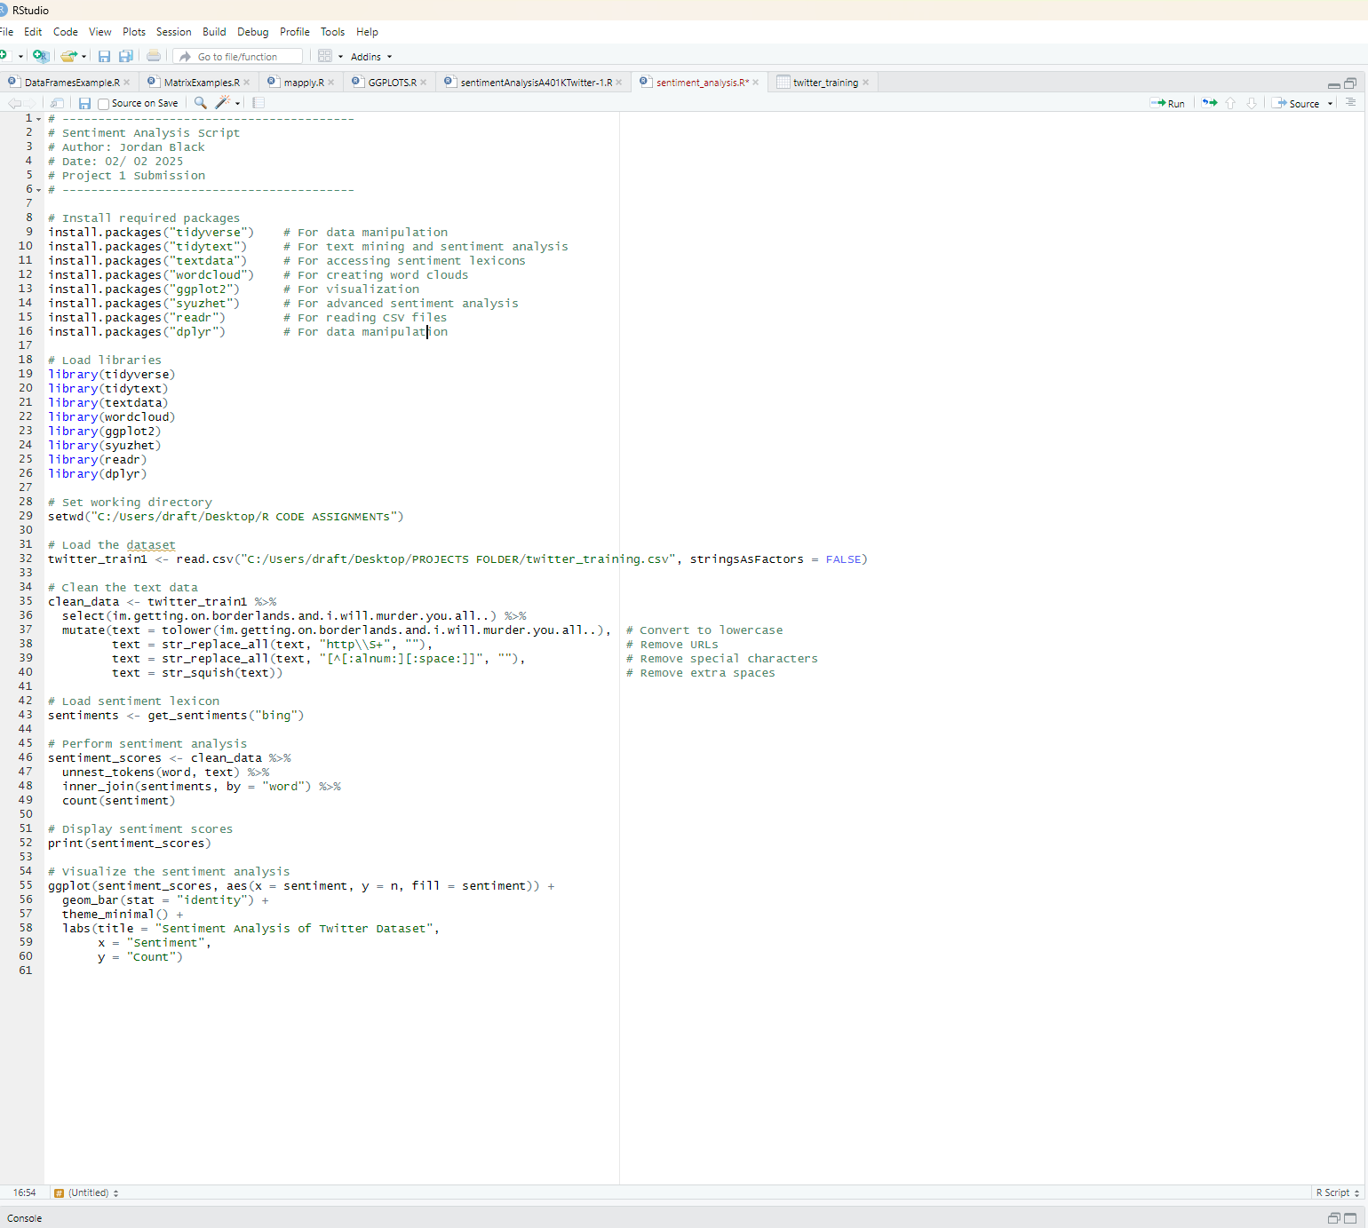

**Screenshot of R Code:**

**Extra Screenshot:**

**Exported GGplot:**

**Screenshot of Twitter training:**

**Screenshot of Console:**

**Removed the extra unnecessary Console code:**